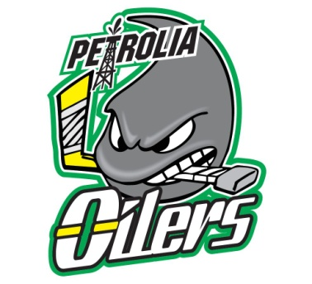

PMHA 2017 Boys Tryout Schedule

**Petrolia Ice slated to be ready for Saturday Sept 16/16
**Shamrock Rep/AE League potential start Sept 22/17 weekend **
**Midget Rep/AE potential start Oct 6/17 weekend**

Tentative Tryout Schedule
Novice Rep
#1 Mon Aug 21 5-5:50pm (Clearwater Arena – Red)
#2 Wed Aug 23 7-8pm (Lambton Shores - Forest)
#3 Thurs Aug 24 7-8pm (Strathroy – Green)

Atom Rep
#1 Mon Aug 21 6-6:50pm (Clearwater Arena – Red)
#2 Tues Aug 22 7-8:10pm (Lambton Shores - Forest)
#3 Thurs Aug 24 7-8pm (Lambton Shores – Forest))

Pee Wee Rep
#1 Mon Aug 21 7-8pm (Lambton Shores)
#2 Wed Aug 23 7:30-8:50pm (Strathroy - Green)
#3 Thur Aug 24 8:10-9:20 PW (Stathroy – Green)

Bantam Rep
#1 Mon Aug 21 8:10-9:20pm (Lambton Shores – Forest)
#2 Tues Aug 22 8:20-9:20pm (Lambton Shores – Forest)
#3 Thurs Aug 24 8:10-9:30pm (Lambton Shores - Forest

Midget Rep
#1 Mon Aug 28 9:20-10:20pm (Watford)
#2 Wed Aug 30 9:30-10:20pm (Watford)
#3 Tues Sept 5 9:10-10:45pm (Mooretown #2)
#4 Wed Sept 6 9:10-10:45pm (Mooretown #1)

Novice AE
#1 Mon Aug 28 5:30-6:40pm (Watford)
#2 Tues Aug 29 5:30-6:40pm (Watford)
#3 Wed Aug 30 5:30-6:40pm (Watford)

Atom AE
#1 Mon Aug 28 6:50-8pm (Watford)
#2 Tues Aug 29 6:50-8pm (Watford)
#3 Wed Aug 30 6:50-8pm (Watford)

Pee Wee AE
#1 Mon Aug 28 8:10-9:10pm (Watford)
#2 Tues Aug 29 8:10-9:20pm (Watford)
#3 Wed Aug 30 8:10-9:20pm (Watford)

Midget AE
#1 Friday Sept 15 7:40-9:10 pm Watford
#2 Saturday Sept 16 6:20-7:40 pm in Petrolia
#3 Sunday Sept 17 8:30-10 pm in Petrolia
#4 Wednesday Sept 20 9:40-10:50 pm Petrolia

