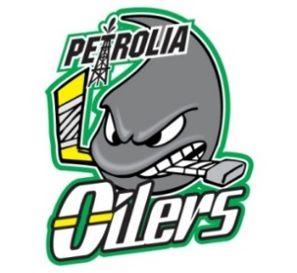

FAIR PLAY CODE FOR PLAYERS
I will play hockey because I want to, not just because others and coaches want me to.
I will play by the rules of hockey, and in the spirit of the game.
I will control my temper – fighting and “mouthing off” can spoil the activity for everybody.
I will respect my opponents.
I will do my best to be a true team player.
I will remember that winning isn’t everything. Having fun, improving skills, making friends, and doing my best are also important.
​I will acknowledge all good plays/performances – those of my team and of my opponents.
I will remember that coaches and officials are there to help me. I will accept their decisions and show them respect.
FAIR PLAY CODE FOR SPECTATORS
I will remember that participants play hockey for their enjoyment. They are not playing to entertain me.
I will not have unrealistic expectations.
I will remember that players are not professionals and cannot be judged by professional standards.
I will respect the officials’ decisions and I will encourage participants to do the same.
I will never ridicule a player for making a mistake during a game.
I will give positive comments that motivate and encourage continued effort.
I will condemn the use of violence in any form and will express my disapproval in an appropriate manner to coaches and league officials.
I will show respect for my team’s opponents because without them, there would be no game.
I will not use bad language, nor will I harass players, coaches, officials or other spectators.
FAIR PLAY CODE FOR PARENTS
I will not force my child to participate in hockey.
I will remember that my child plays hockey for his or her enjoyment, not for mine.
I will encourage my child to play by the rules and to resolve conflicts without resorting to hostility or violence.
I will teach my child that doing one’s best is as important as winning, so that my child will never feel defeated by the outcome of the game.
I will make my child feel like a winner every time by offering praise for competing fairly and trying hard.
I will never ridicule or yell at my child for making a mistake or losing a game.
I will remember that children learn best by example.
I will applaud good plays and or performances by both my child’s team and their opponents.
I will never question the official’s judgment or honesty in public.

FAIR PLAY FOR COACHES & TEAM OFFICIALS
I will be reasonable when scheduling games and practices, remember that players have other interests and obligations.
I will teach my players to play fairly and to respect the rules, officials and opponents.
I will ensure that all players get equal instruction, support and fair playing time.
I will not ridicule or yell at my players for making mistakes or for performing poorly.
I will remember that players play to have fun and must be encouraged to have confidence in themselves.
I will make sure that equipment and facilities are safe and match the players’ ages and abilities.
I will remember that participants need a coach they can respect.
I will be generous with praise and set a good example.
I will obtain proper training and continue to upgrade my coaching skills.
I will work in cooperation with officials for the benefit of the game.

