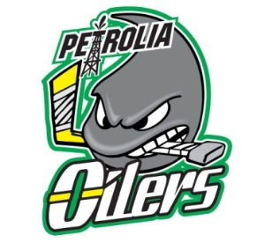

Petrolia Minor Hockey Association in partnership with Troy’s Run Foundation is pleased to be hosting a “Concussion & Baseline Testing Conference and Information Evening” with Dr. Michael Hurley & ABI Specialist Troy Adams' on Wednesday, September 17/14 at the Petrolia Lion’s Hall
What: Concussion & Baseline Testing Conference and Information Evening (including a showing of the acclaimed documentary “Head Games”)
When: September 17/14
Where: Petrolia Lion’s Hall
Time: 6:30 PM
Who Should Attend: Any PMHA coach, trainer, parent or player interested in finding our more about concussions and concussion protocol.
Cost: Free

For more information or to RSVP please contact Nick Salaris at salaris1@hotmail.com by September 12/14.

