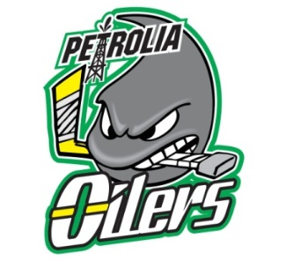
Hello all…
I am again looking into getting PMHA hockey, goalie bags coach’s bags for anyone interested. The bags are from Eagle Hockey in London. The bags are:
- Black and bag made from sterling (which is what the pro's order) and
- The size is 31" X 20" X 15" for player bag, 40" x 24" x 20" for goalie bag and 24" x 15" x 12" for coaches bag
- With ID windows, end handles and Velcro closures
- Comes with Eagle logo on both sides and PMHA logo on one side
Cost is $104 for player bag, $115 for goalie bag and $87 for coach’s bag (includes HST and delivery to Petrolia). Minimum 12 bag order to guarantee the price!
- Delivery time is approx. 4 weeks
- You can go to the catalogue on the website www.eaglehockey.com. The code for the player bag is LPL10, for goalie bag is LGB10 and coach’s bag is LCB10 or see them below.
- Please let me know salaris1@hotmail.com if interested by Nov 2/14. I will need $ prior to placing the order. I ordered some last year and this year – if you want to see finished product let me know.
- Makes a great gift!

** Please note that this not part of any fundraising effort**
Player Bag - LPL10 Goalie Bag - LGB10 Coach’s Bag - LCB 10
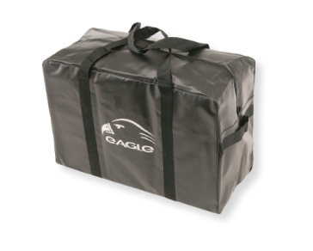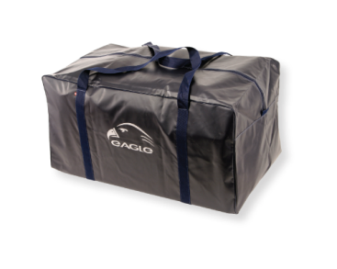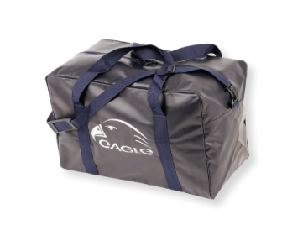

Nick Salaris
President
Petrolia MHA
salaris1@hotmail.com

