Summer Skates for Sale
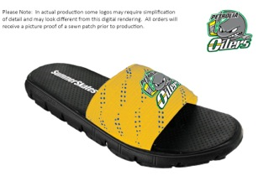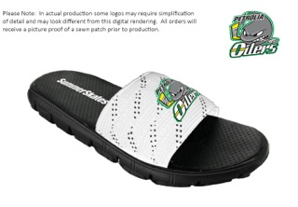

Summer Skates are available for sale at the Greenwood Rec Centre during the months of November & December during peak times. To view sizing samples and order yours with or without the Oilers logo stop by the table at the arena or email sarah.busby@live.com to arrange a time to see the samples or submit your order.
Sandals are available in; Yellow with Blue marks, Red with Blue, Black with Blue, Pink with Blue, and White with Blue, Red, or Black marks. The Oilers logo can be added to any colour.
Sizes range from XS (3-4), S (5-6), M (7-8), L (9-10), and XL (11+)

Sandals sell for $35; SummerSkates provides a portion of net sales to Fight Cancer through Road Hockey To Conquer Cancer and Movember, profits support the Atom Tri-County team.

Call Sarah at 226-402-3405 with any questions, or email sarah.busby@live.com
**Note: Orders will be submitted by November 24th to ensure delivery for holiday gift giving

